3.Software Methodology

3.1. Software Methodology

A software methodology is kind of framework that’s is used for software development which helps to do the developing in structure, plan and control the process of developing(Professionals, n.d.). Using software methodology, we will get a tracking of the development of the software.

There are plenty of process out there to manage or develop a software, thus it is impossible to find a particular way of development. Software methodology will reduce the risk of project by cutting down the process into smaller, this will help to develop the software more easier and easy of changing the development any time (alliancesoftware, n.d.).

It is very hard to find which methodology we have to follow the development, but it can be solved by understanding the all the software development methodology. Working under a development methodology will help the client and the developer to deliver a well-organized software and well discipline code.

We have decided to choose Rapid Application Development(RAD), is a form an agile software development, which works on user feedback and strict planning and freezing the requirements. In short, we can say Rapid Application Development(RAD) is “less talk more action “. But it need more testing for the software because it is built in fast paced environment. (Anderson, 2017)

RAD is mainly focus on the software development rather than the planning, requirement is generally freeze so that it helps to start the prototyping. RAD methodology generally breaks the project into small task, where it can be accomplished more quickly. As a result, this will give effective communication, faster development and better efficiency. (Team, 2018)

**Generally, Raid Application Development focused follow four main phases**:

1.Requirement planning:

2.User design

3.Rapid Construction

4.Cutcover

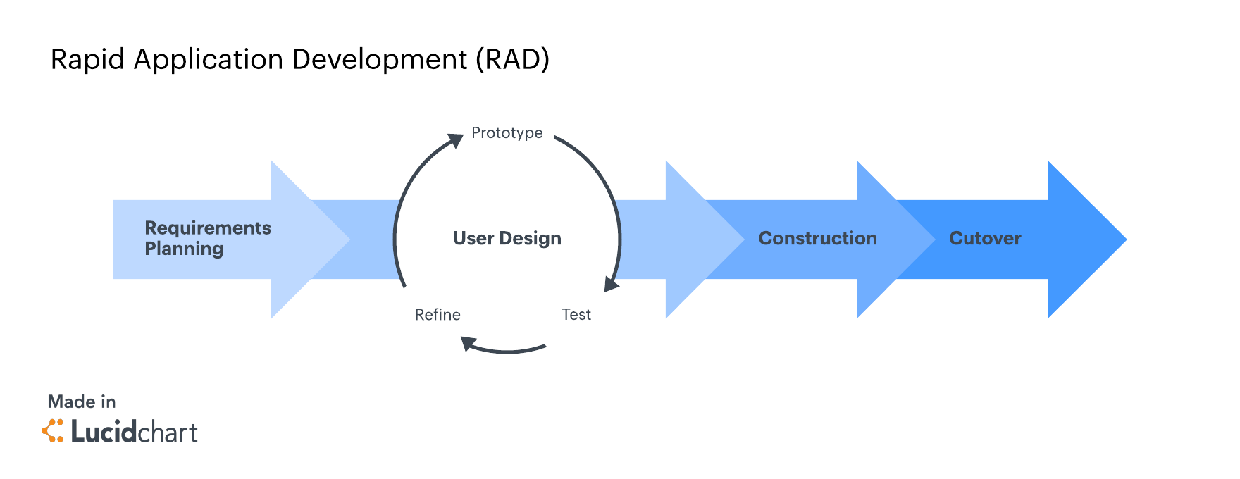

Figure 1 :Rapid Application Methodology Phases (Team, 2018).

1.Requirment Planning:

This is critical step because in RAD there is no regular meeting for the requirement planning, when a meeting is called client, developer and design will come together and discus about the project and break down the stages that involves in the project. And also, they make sure to freeze the project so that they can start the prototyping the project. (Team, 2018)

2.User Design:

So once the requirement is fixed, they jump into the development and start the prototyping the various design. This will be working more closely with client, to make sure developer are meeting the all the requirement and changes that client needs. (Team, 2018)

3.Rapid Construction:

After the design meeting all the requirement it’s the time to start the rapid development, In this stage the development will be in fast pace. The software development team start the coding, integration and testing and also work together to make sure everything goes as per the plan. This stage is very important because client get the beta application where he can make changes or rise and issue before it goes live. (Team, 2018)

4.CutOver

This is the last stage of the development, where is product comes in finished state and move to live environment. In this stage product will be moved into the new system, data conversions, and may also give training to the users. (Team, 2018)

4.Resourses

4.1: Swift

iPhone use iOS as the operating system which is created and developed by the Apple Inc. To develop an iOS mobile application, we use SWIFT as the languages. Swift is open source modern language which works in high performance and powerful. Swift is also replacement of C – based language. (Apple, 2018)

4.2: Xcode

The Integrated Development Environment(IDE) that used for the iOS development is Xcode. Xcode is developed by the Apple Inc., using Xcode we can also develop application for MacOS and iOS application (iPhone, iPad, iWatch). Using Xcode we can develop, Test and publish the application into the iPhones. This Tool are used for apple products development which have many features that helps the developer to build first class apps to the users.

Some of the futures are (Apple, features, 2018):

* Simulator
* Compelling and Easy Fix it
* Graphical debugger and Data Recording
* Direct repository
* Unit Testing and Unix tools

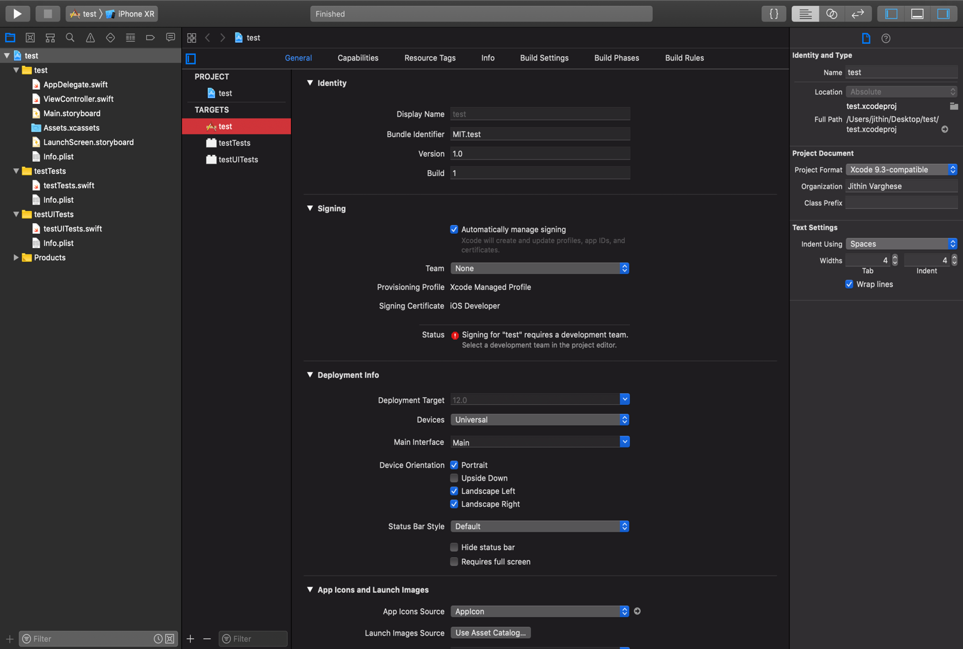

Figure 2 Xcode

4.3 Apple Store

iOS application can be downloaded from apple store. Apple store is created by Apple Inc. After completing the application developers publish the app in to the apple store. Where iPhone users can download application to their Phone.

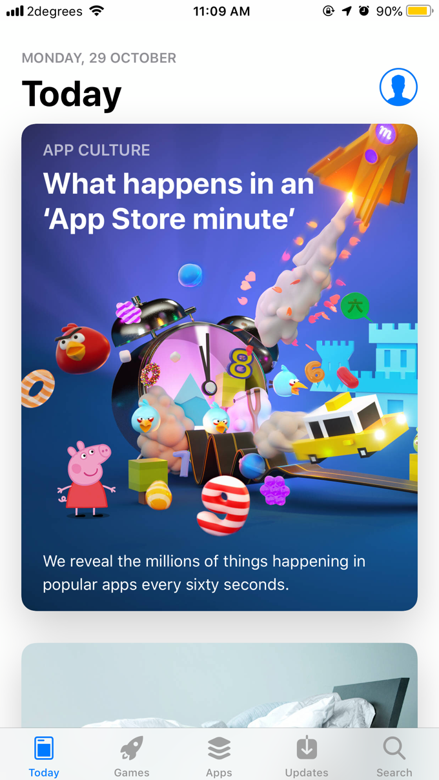

Figure 3 Apple App store

4.4 JavaScript Object Notation(JSON)

JSON is used as a hub between the presentation layer and data layer to be more clear

JSON is used to exchange the data between the mobile application and server, it transfer the data in text format. We use PHP as the languages to get the JSON format text, PHP have built in function to get the JSON . (w3schools, n.d.) (w3schools, JSON PHP, n.d.)

GANTT CHART

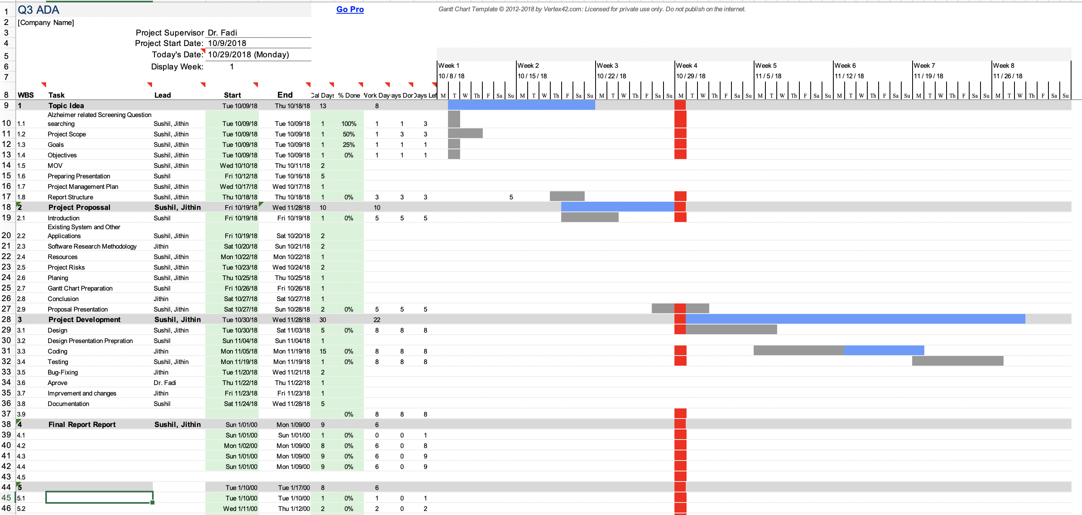

1.Alzheimer’s Disease Pocketcard

This app helps the physicians and other health care professionals care for patients with Alzheimer’s Disease at the point of the care. This app has clinical based information on Alzheimer’s Disease and have interactive tool to help the efficiency of the clinical tests that can be assess by the patients and the care taker. This app main advantage is that it is collaboration between the Alzheimer’s associations and Borm Bruckmeier. Main advantage of this app ,if you give email address it will provide the education and support details from Alzheimer’s association. It also used DSM 5 guidelines and criteria. To help clinicians they have developed an algorithm for visiting annually with the help of professionals. (LLC, 2017)

Even though there are many traits of applications, but it is very completed and not an easy app for a layman it requires health care professional assistance .App is not user friendly and it follows an out dated designs navigation always are very confusing it doesn’t go back to the original positions. And some of the features and not available in iPhone they are forcing the user to move into the iPad.

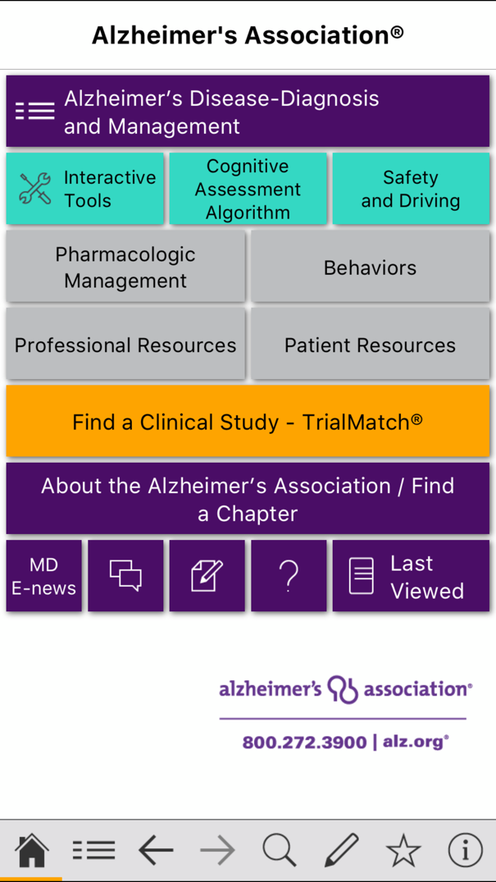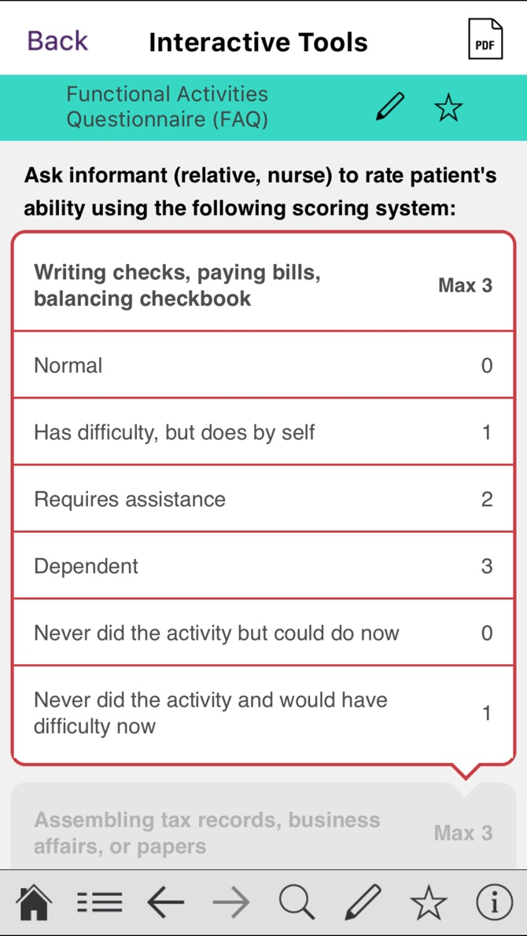

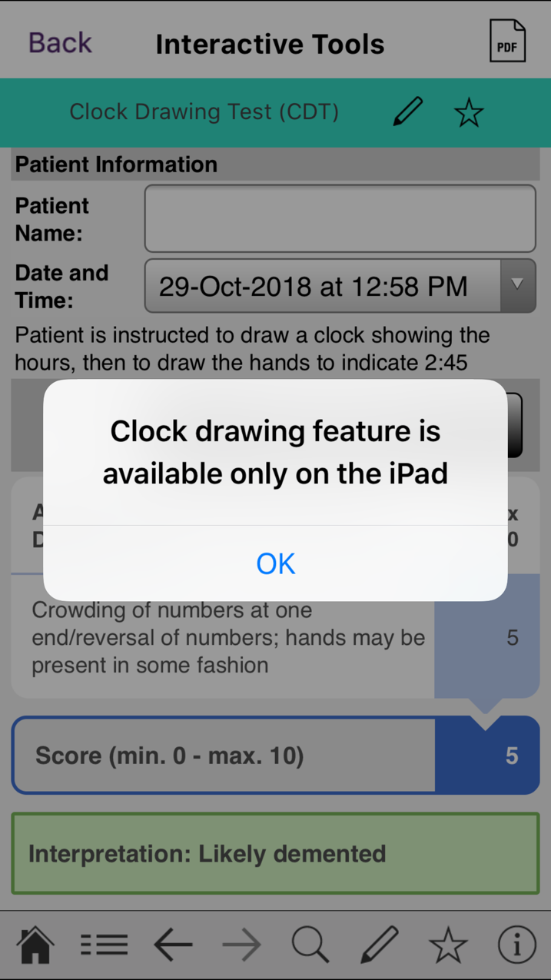

# 2. Alzheimer's and Dementia Tips for Families

# This app is to help the families by providing Alzheimer's and Dementia video tips ,so that they can advise the caregiver of Alzheimer's and Dementia patients.it have heaps of topics and questionnaires practical advice videos which helps the caregiver. By watching the videos the family members of affected patients will get educated more on Alzheimer's and Dementia disease and its behaviours pattern of the patient. (Ericksen, 2016)

# Even though app is informative it doesn’t contain any pre diagnosed methods or screening test which helps to assess the patients’ health improvements. This app is not dynamic, it downloads all the videos within the app, it make the app to load more time and it effects the memory if app as well as the storage capacity of the application.

# 

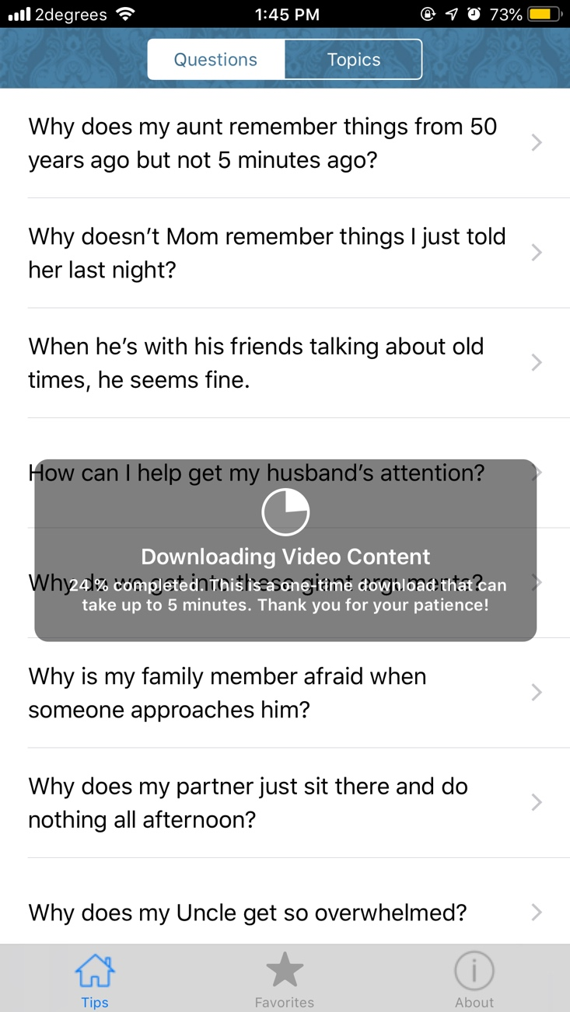

3. DementiAssist

This app is mainly focus on the  person with dementia. This app is contain many behaviours ,possible caused suggested actions of the person with dementia. It all so cover all the behavioural expressions ,so that care taker and notice the patient possible behaviours expressions. This also provide the actions that to be noticed. The most unique of this app is that this app shows about the behaviours expression of person with dementia. It help the healthier person to observe the expression and understand the health state (CENTER, 2015).

Even though they provide the actions for triggers ,it will be great if they add more detail for the actions, in this app most of the actions a one line sentence ,which some time are not much clear to the care taker. This is app is last version release was on 3 years back, it will be good if they update periodically which helps the app improvement and design.

